**Fatima Jinnah Women University**

Department of Software Engineering

**LAB EXERCISE 1**

**Name:** Raifa Khalid

**Reg. no:** 2020-BSE-024

**Section:** A

**Semester:** Fourth

**Course:** Data Base (LAB)

TASK 01

Create a database having following tables.

* Department (Representing different departments of university)

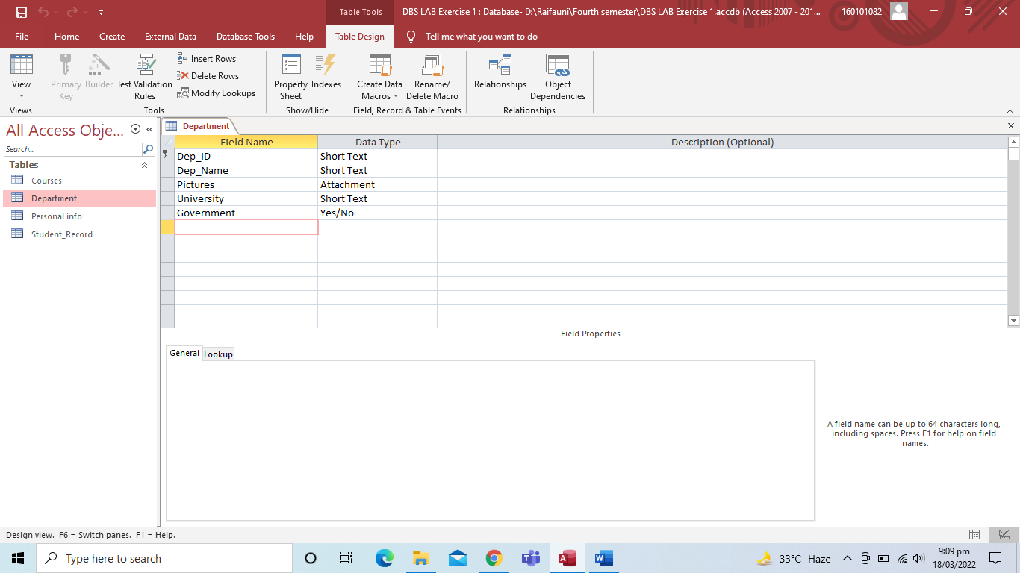

* Courses (Representing courses for different departments)

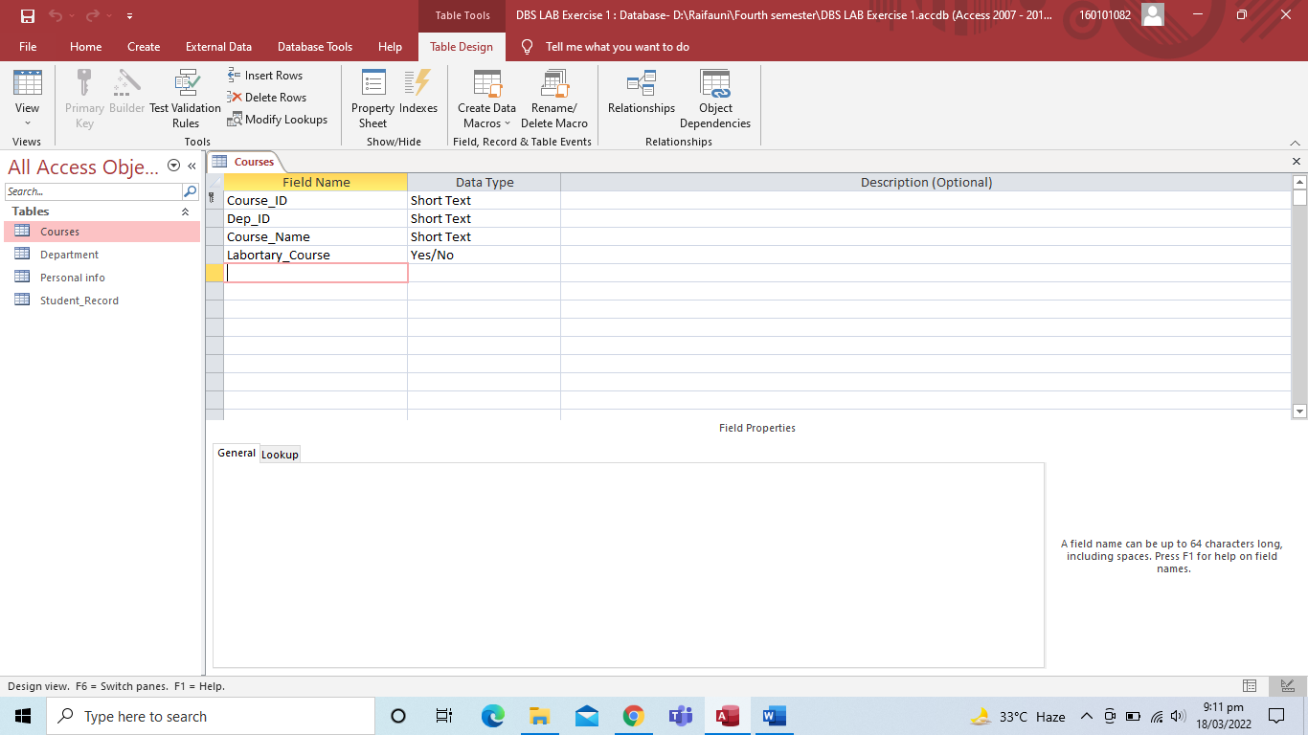

* Personal Info (Representing personal info of student)

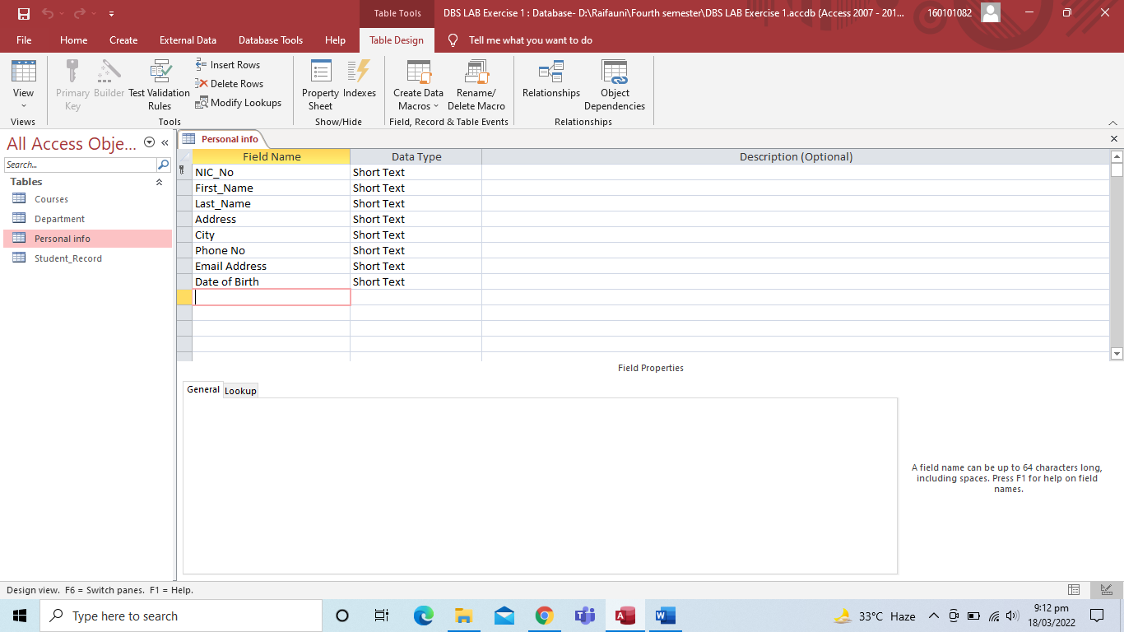

* Student Record (Representing course GPA of specific student)

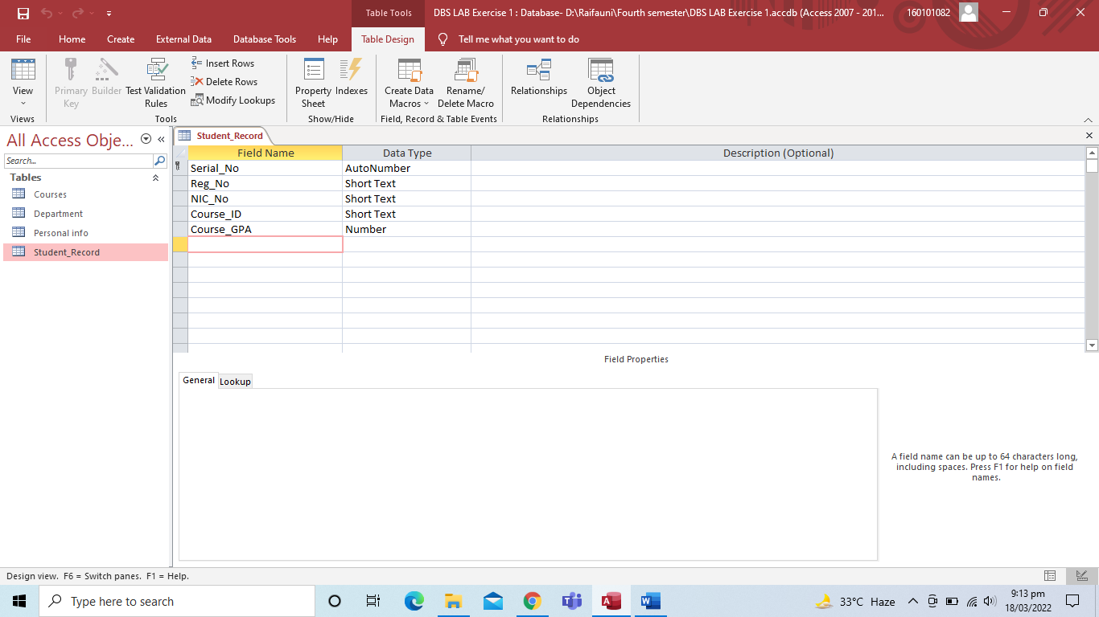

TASK 02

Assign the following dep_Id to the following departments and insert the data for other related fields.

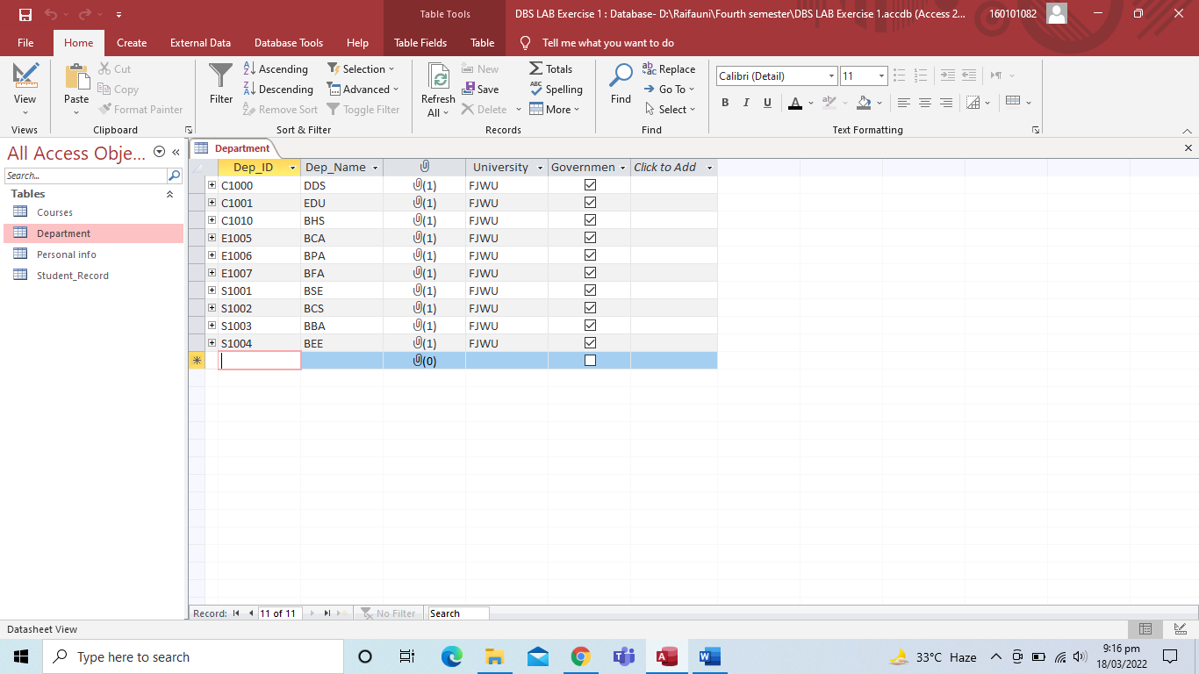

TASK 03

Assign six courses to each department representing the courses for each department (first semester) and insert the data for other related fields.

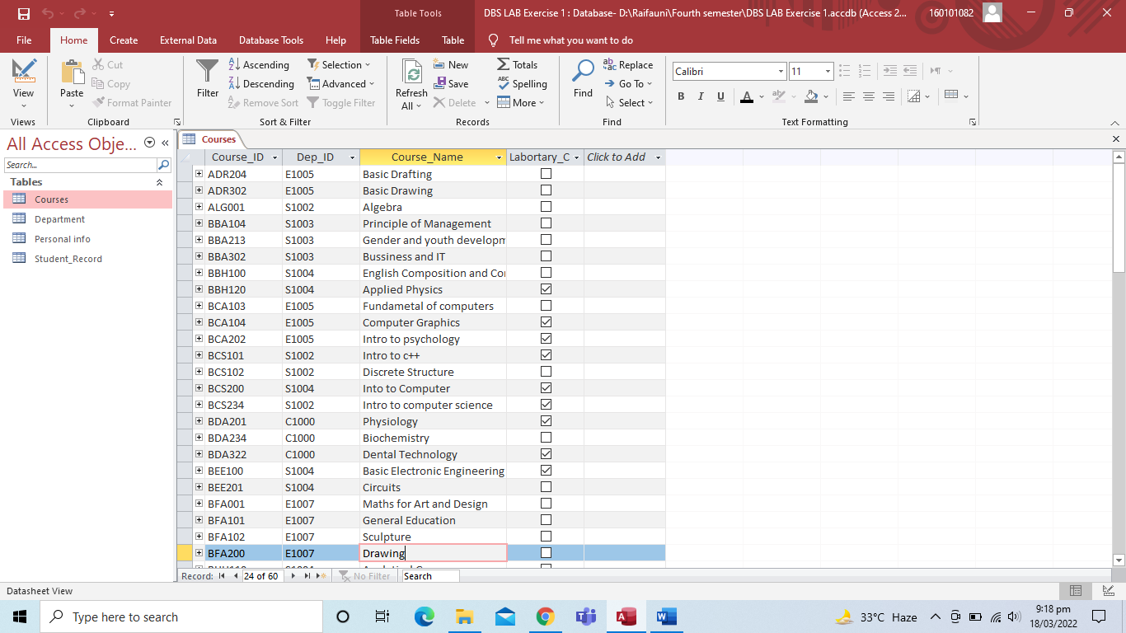

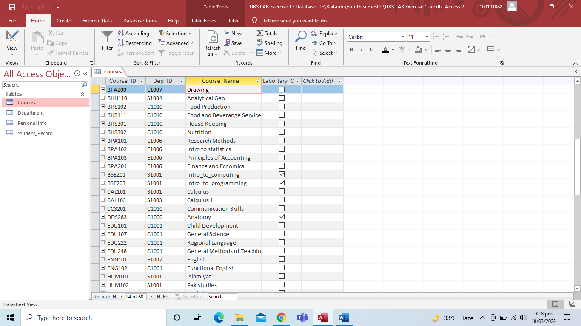

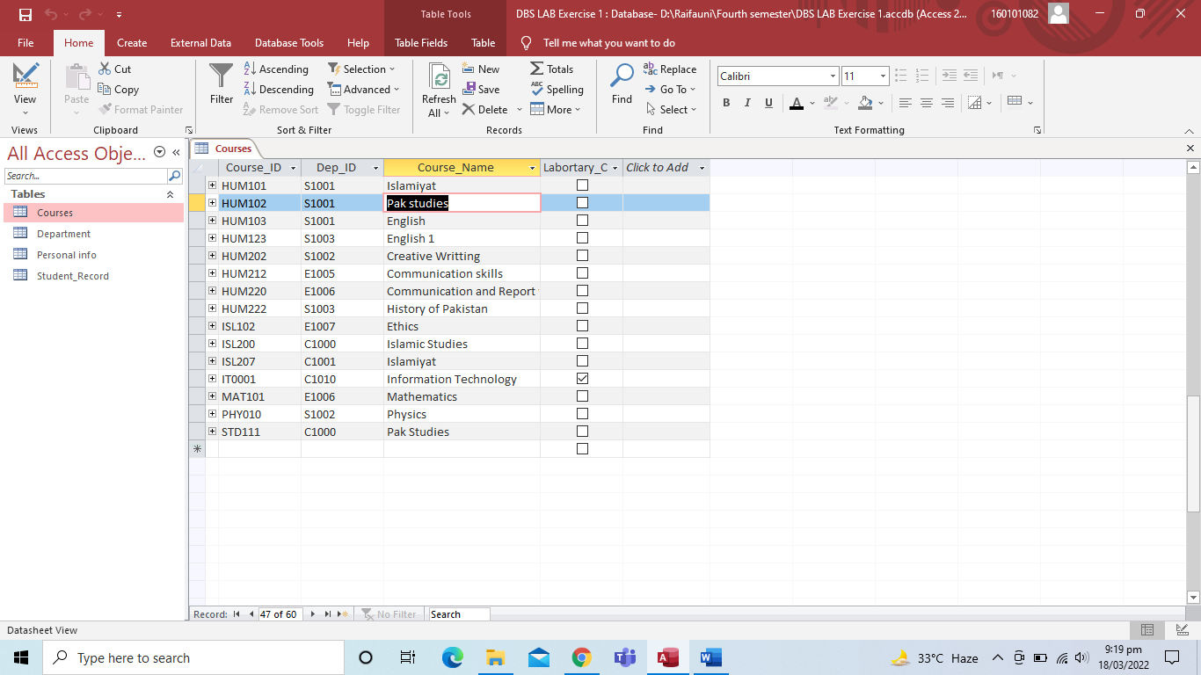

TASK 04

Insert data for 30 students in personal info and student record table, 3 students of each department.

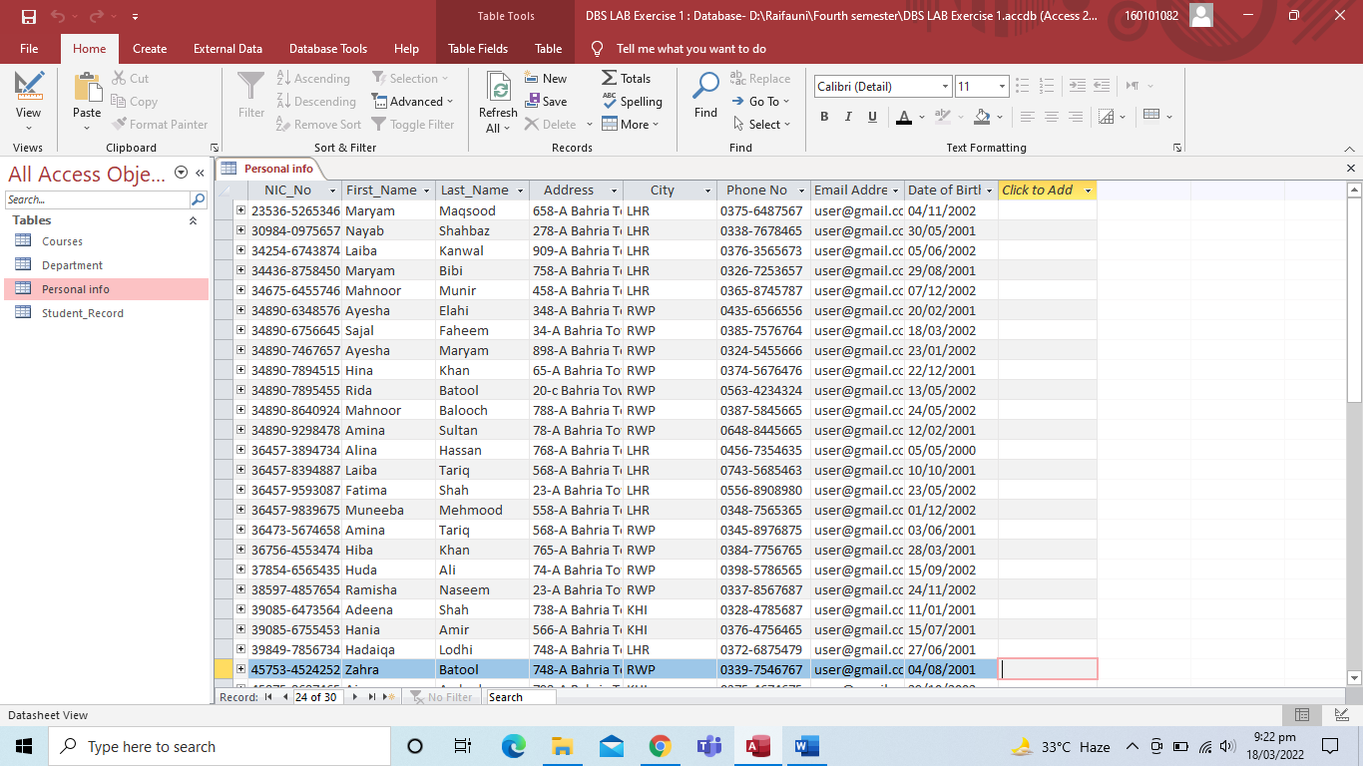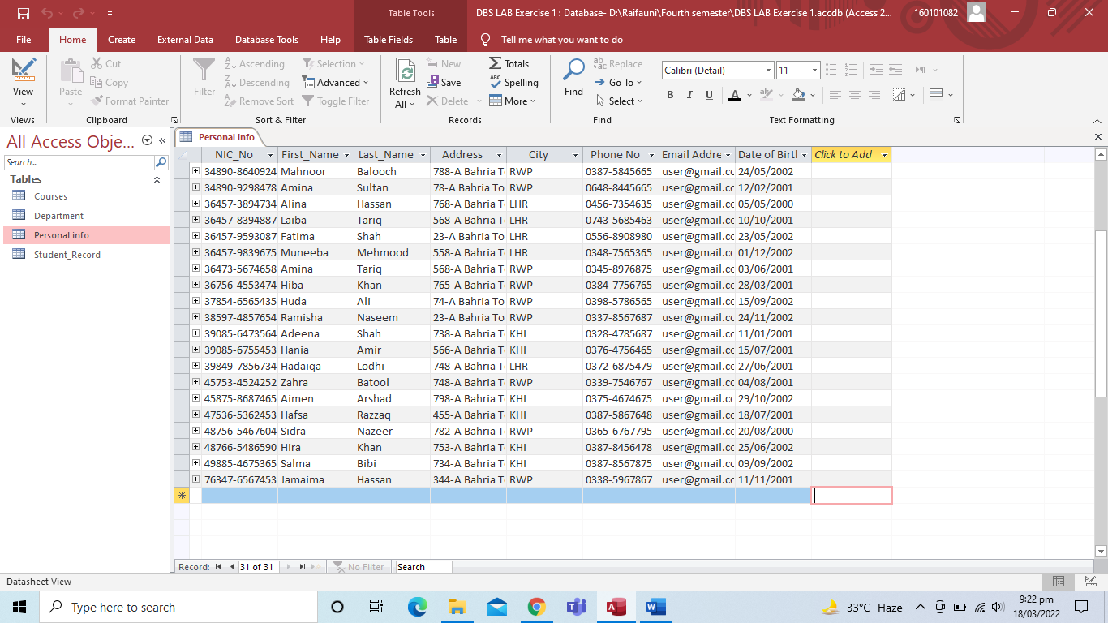

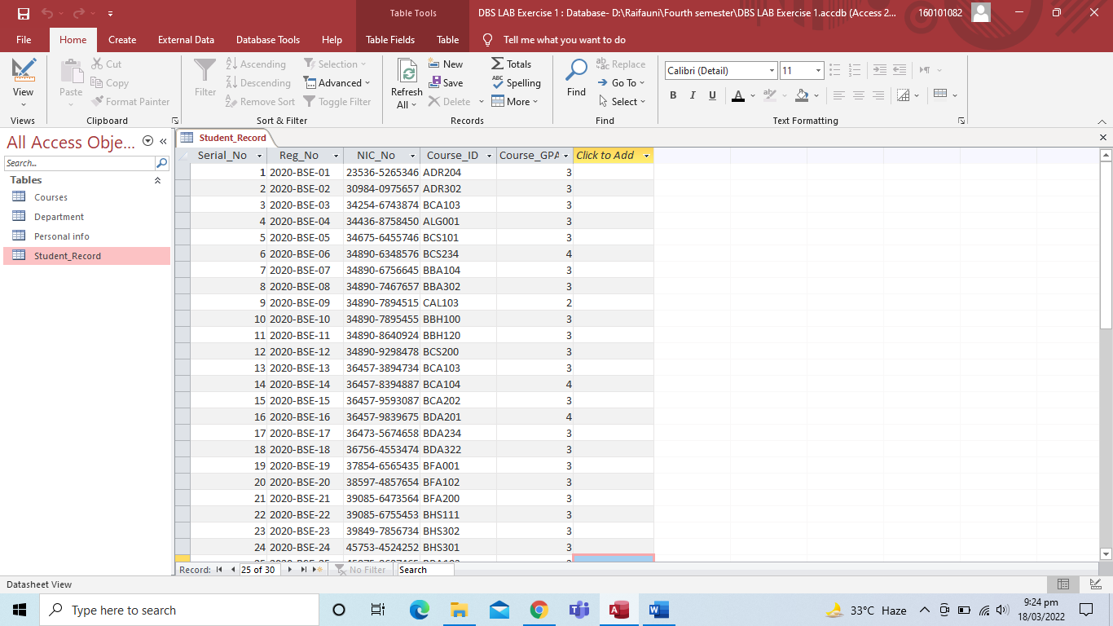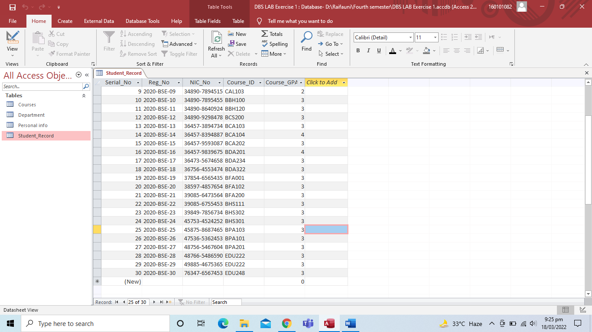

TASK 05

Create the relationship between the tables created above and also make sure “Enforcement of referential Integrity”.

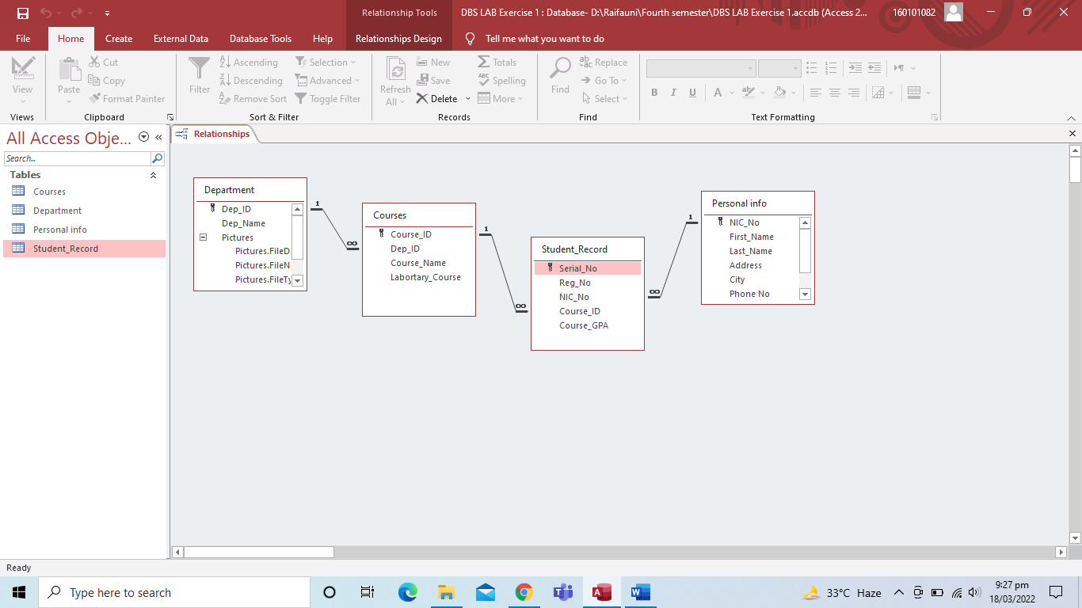

TASK 06

a. Sort all the students record according to GPA

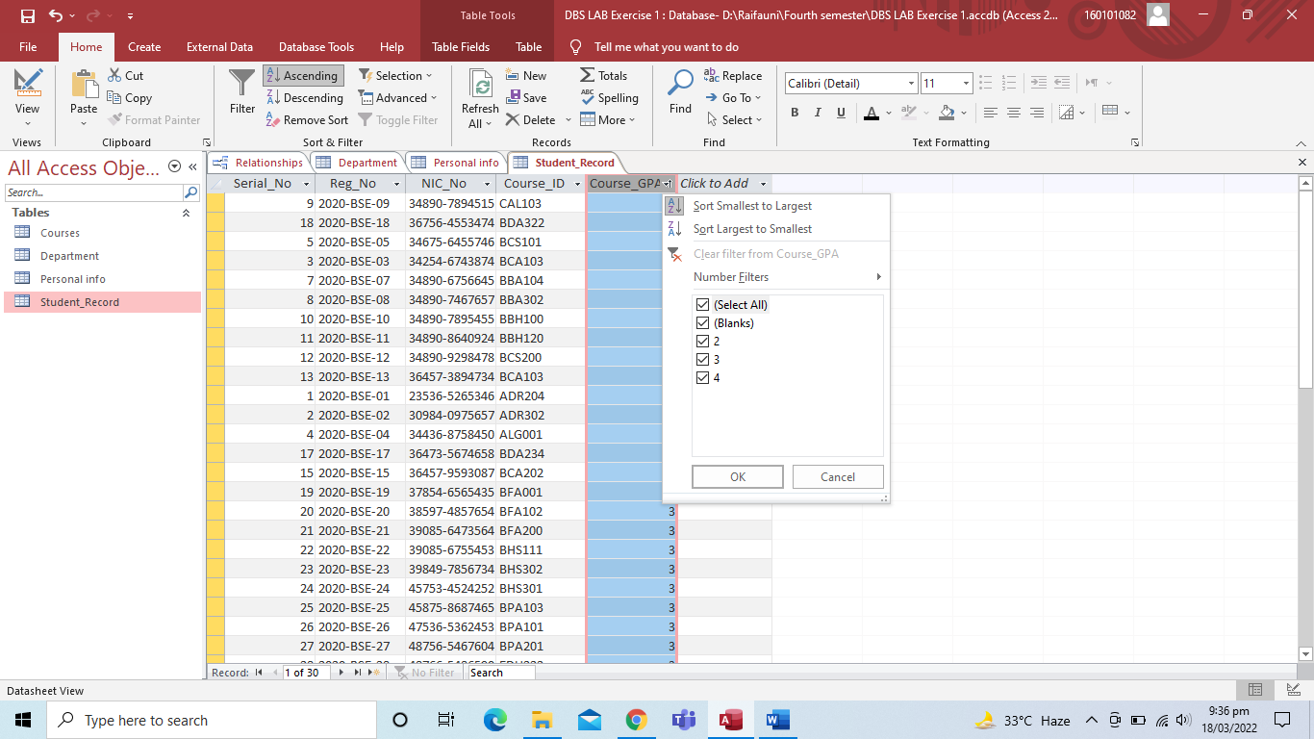

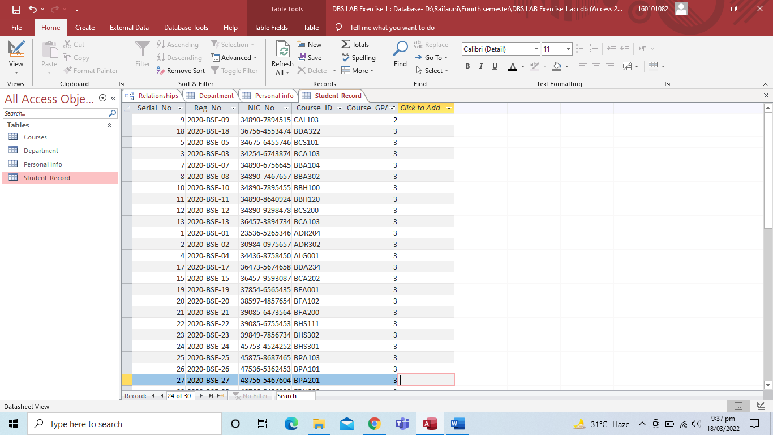

b. Sort all the student Alphabetically

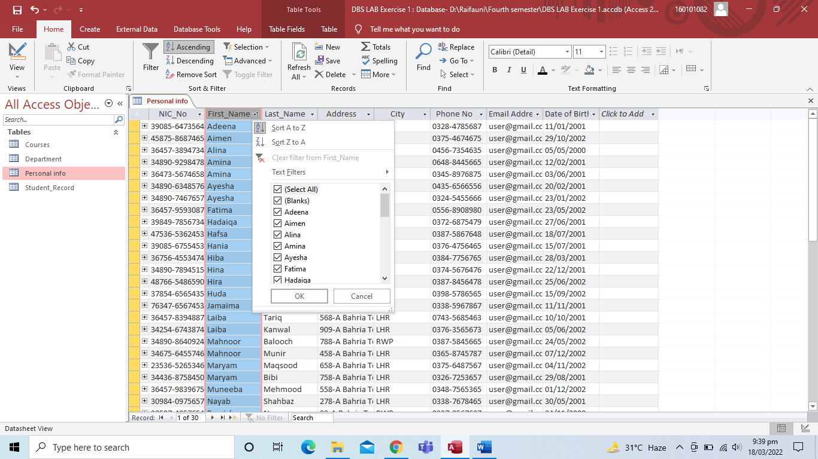

c. Filter all the students records for BSE only

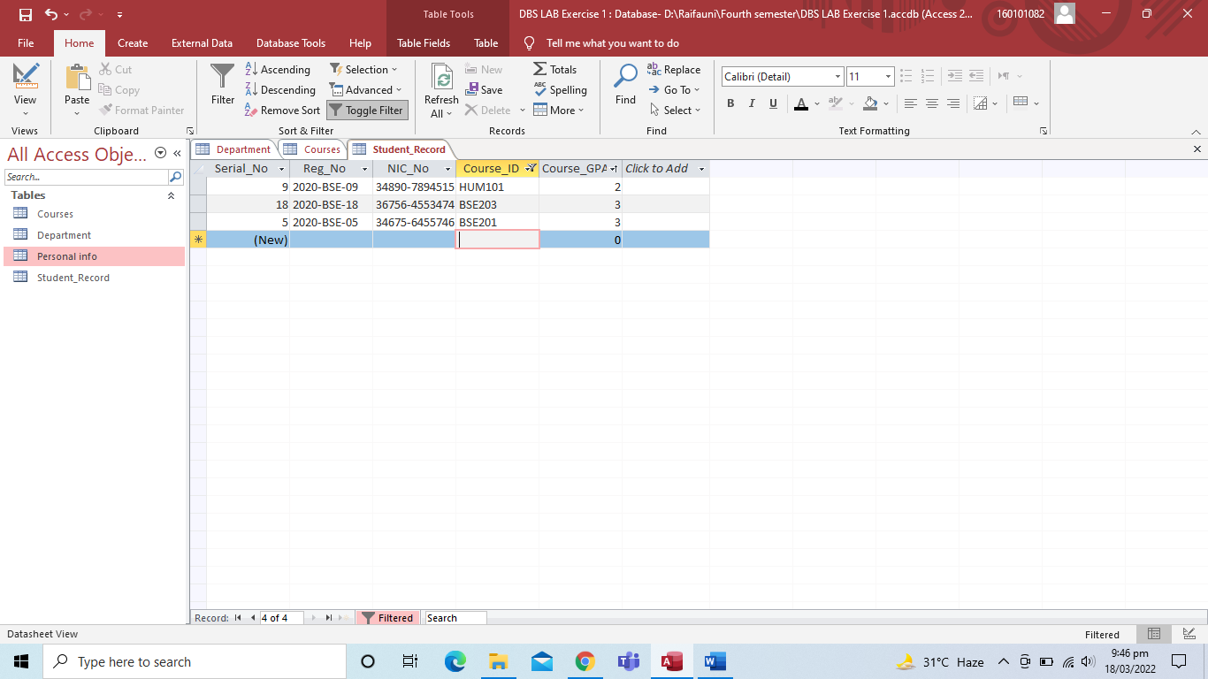

d. Show all students records having registered course PF only

